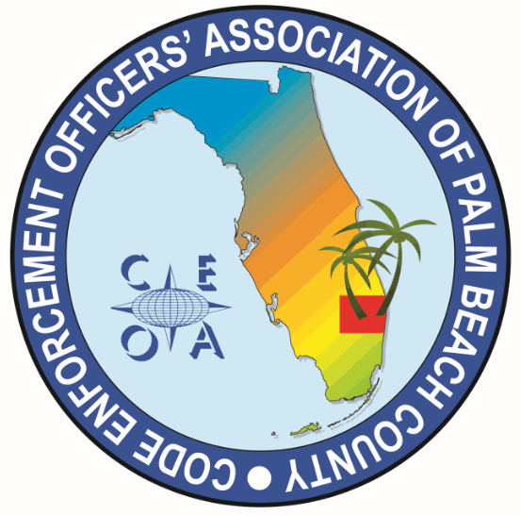
CODE ENFORCEMENT OFFICERS ASSOCIATION
OF PALM BEACH COUNTY
BOARD MEETING AGENDA
APRIL 9, 2024
1:00 PM
2300 N. JOG RD, WEST PALM BEACH, FL 33411

Call meeting to order, roll call, establish a quorum

Approval of annual meeting minutes from March 21, 2024

Treasurer report – Joe Oliva

OLD BUSINESS

- 35TH Annual F.A.C.E Conference June 11th through 14th

- Sponsorship Gold Sponsor; Contact F.A.C.E and send payment
- Number of board members we are sending; payment to F.A.C.E for board members
- Conference table responsibilities and raffle item
- Gift Card Purchase. How many need to be purchased
- Donation for CEOAPBC members who are running for
F.A.C.E board

Page 2
2. Future training topic and location – Micheal Jordan
NEW BUSINESS
3. By-law reading and review
4. Sunbiz, ICC, Planning Congress, A.A.C.E update
5. Chapter page on F.A.C.E. website
a) Headline paragraph on chapter page and Board of Directors has
been updated
b) Secretary to send agenda and minutes to Mike Ryco after each
meeting to post of website
c) Membership application needs to be posted on website
d) Training announcements need to be sent to Mike Ryco
e) Consideration of creating a mission statement for our chapter to
be posted on our opening paragraph on our chapter page

6. Discussion and consideration of creating a certificate after each training session.

7. Items to be considered at next board meeting. Set a tentative date and time for next meeting prior to the conference.

Adjournment

